**SAVEETHA SCHOOL OF ENGINEERING**

**CSA1142-OBJECT ORIENTED ANALYSIS AND DESIGN**

**QUESTION 9: LIBRARY MANAGEMENT SYSTEM**

**USE CASE**

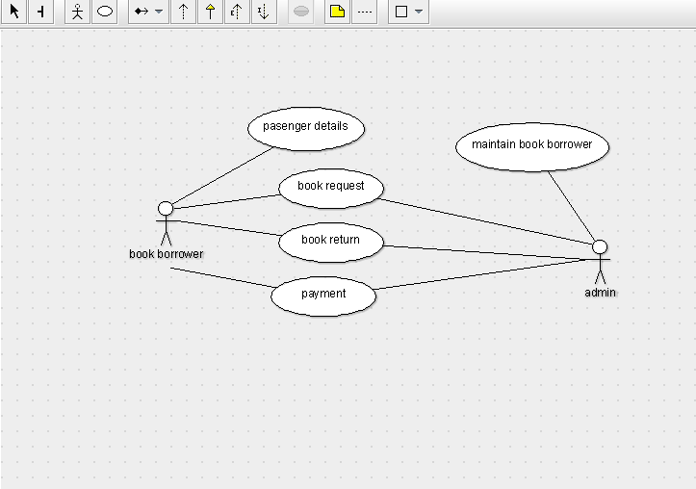

STATE DIAGRAM

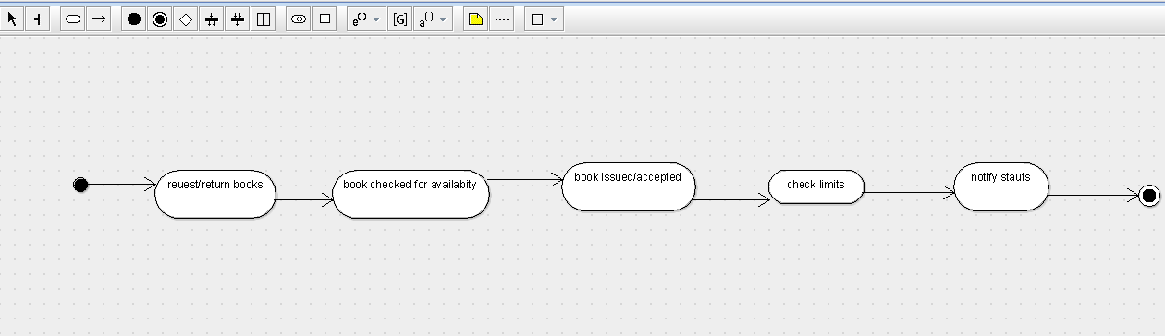

SEQUENCE DIAGRAM

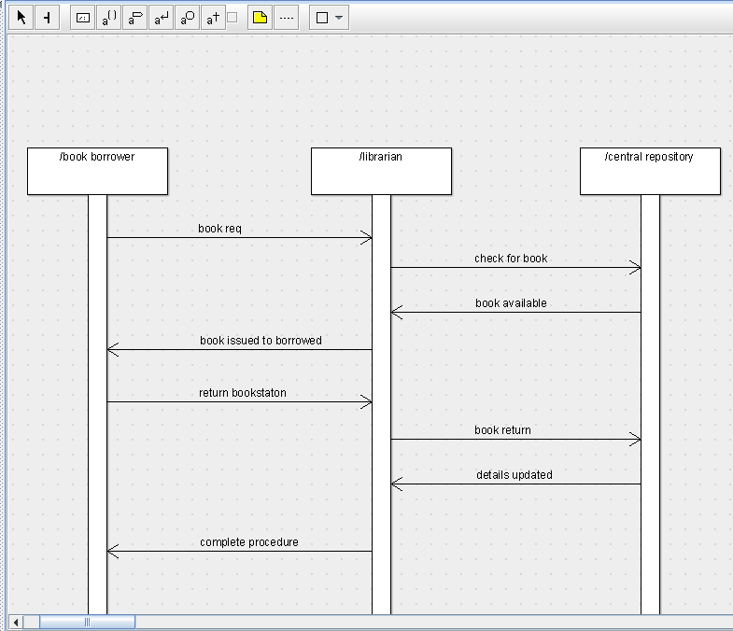

DEPLOYMENT DIAGRAM

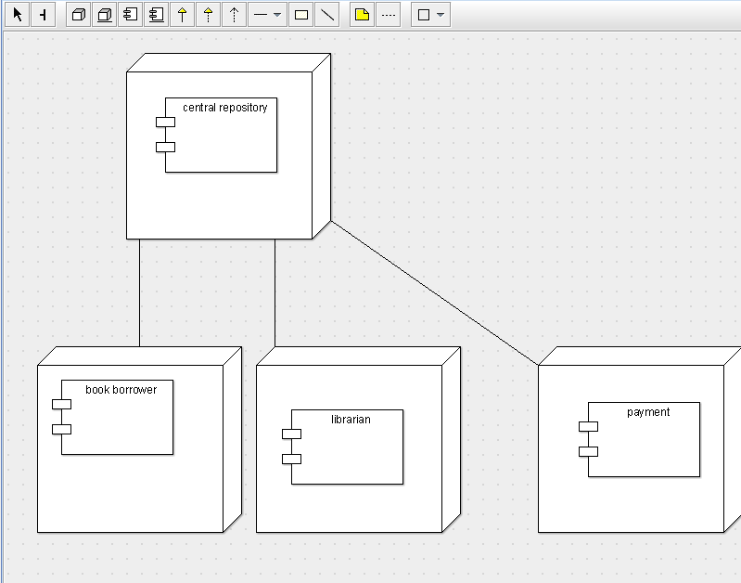

COMPONENT DIAGRAM

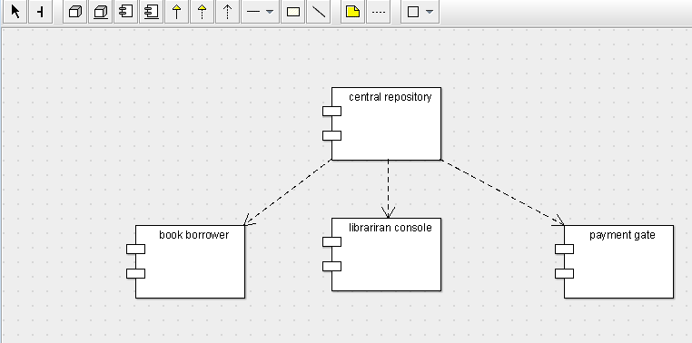

COLLABORATION DIAGRAM

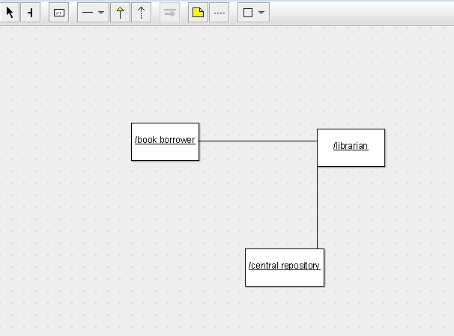

CLASS DIAGRAM

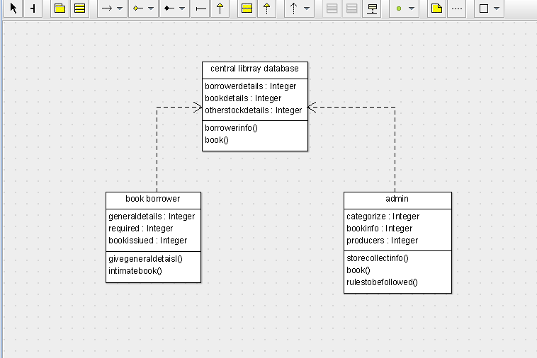

ACTIVITY DIAGRAM

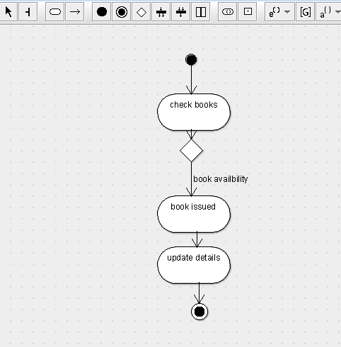

SKELETON CODE;

public class central librray database {

  public Integer borrowerdetails;

  public Integer bookdetails;

  public Integer otherstockdetails;

  public void borrowerinfo() {

  }

  private void book() {

  }

}

public class book borrower {

  public Integer generaldetails;

  private Integer required;

  public Integer bookissiued;

  public void givegeneraldetaisl() {

  }

  public void intimatebook() {

  }

}

public class admin {

  public Integer categorize;

  public Integer bookinfo;

  public Integer producers;

  public void storecollectinfo() {

  }

  private void book() {

  }

  public void rulestobefollowed() {

  }

}